**Software Setup**

1. **Python**
2. **PIP (package manager)**
3. **Django** (a module/package of python)
4. **Code Editor (Atom, VS Code etc)**
5. **MySQL database and MySQL Workbench**
6. **Python mysqlclient** (driver for database connectivity)

**#1. Python**

* **Download and install the latest version.**
* **Confirm the installation by running a command like checking its version**
  + **Users\user>python --version**
  + **Python 3.8.2**

**#2. PIP**

* **It comes by default with Python of version 2.3 or greater.**
* **But it can be downloaded and installed separately also.**
* **Confirm its availability**
  + **Users\user>pip –version**
  + **pip 19.2.3 from c:\users\user\appdata\local\programs\python\python38-32\lib\site-packages\pip (python 3.8)**

**#3. Django**

* **Using PIP, it can be installed like installing other packages of Python**
* **Users\user>pip install django**
* **Confirm the installation**
  + **Users\user> python -m django --version**
  + **3.0.6**
  + **Confirm it from anywhere in the directory**
  + **D:\>python -m django –version**
  + **3.0.6**

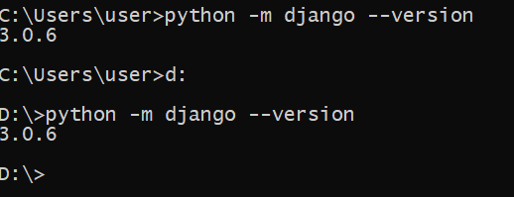

**The Command Prompt**

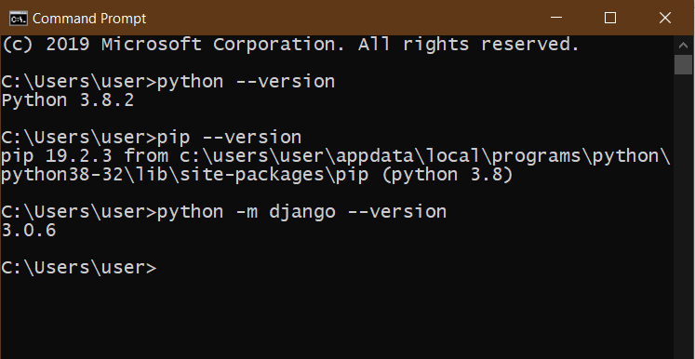

**#4. Atom IDE**

* **Download and install the Atom IDE**
* **Need to install some packages, that will help while coding.**
  + **Go to File 🡪 Settings 🡪 Install**
  + **Search and install these two packages**
  + **autocomplete-python**
  + **atom-django**

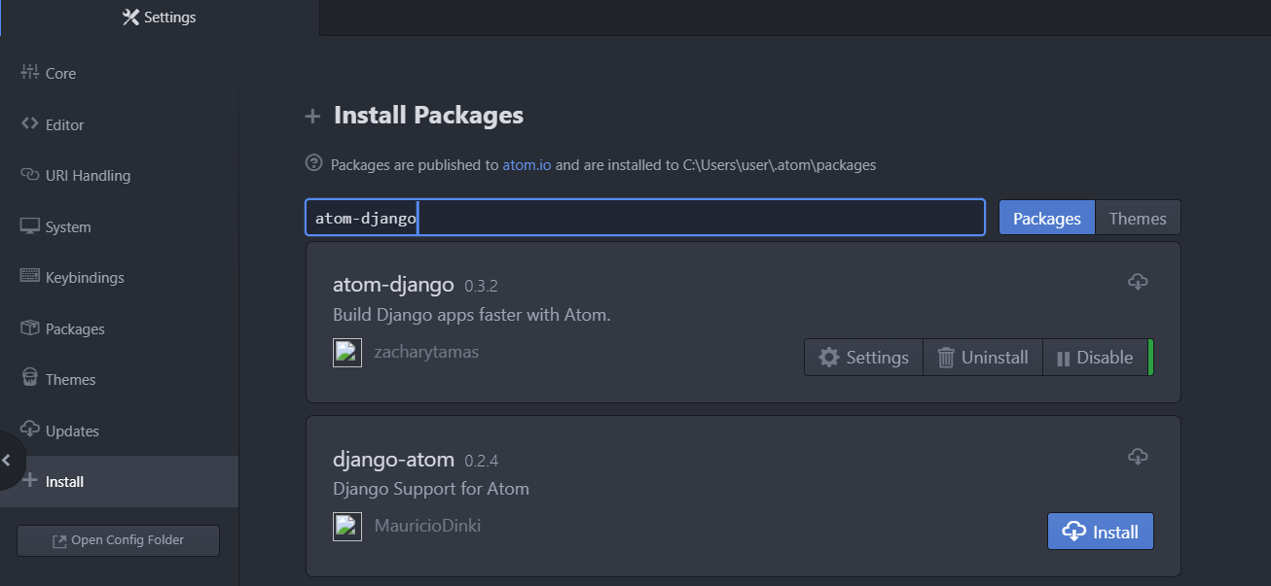

**#5. MySQL DB and MySQL Workbench**

**#6. Python MySQLClient**

* **To connect to MySQL database from within our Django projects or a python application, we need to install mysqlclient (Like mysql connector in Java).**
* **It can be installed using pip installer**
  + **Run the command**
  + **user>pip install mysqlclient**